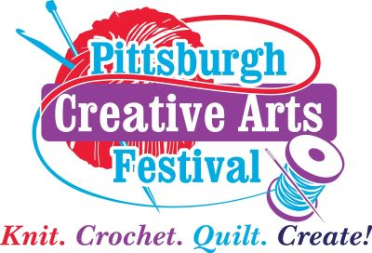 | 2023 Pittsburgh Creative Arts Festival  Class Proposal

Event Dates & Location | August 24-26, 2023  DoubleTree Hotel  Green Tree, PA

Teacher Name
Teacher Address
Teacher Phone
Teacher Email
Estimated mileage (roundtrip)

Terms and Conditions

Teaching Sessions | Thursday/Friday – PM, Saturday AM & PM
Payment to Teacher | Pay rates and reimbursement for teachers will be established with each teacher based on their experience, published materials and individual needs.  Vendors who are teaching will not be reimbursed for travel expenses.
Materials Fee | If classes have material fees, please include in the class proposal. Material fees will be listed in the class registration and are payable to the teacher by the student.  Material fees are any items provided for class by the teacher: patterns, yarns, needles, kits etc  Any kits and accessories: buttons, fibers, patterns may be made available to the student at an additional fee but must be listed in the class description
Classroom Set up | Classrooms will be set up classroom style – please specify if you need a different classroom set up  If you need special equipment, please let us know
Promotional Information | Teacher authorizes Festival host to use Teacher’s name, image, description, and bio information in connection with promoting the event.  Teacher should also promote classes on their social media/webpage
Other items: | You may show any handmade items in your class and advertise any of your upcoming classes at other locations in the future. You may advise your students if you have any yarns/items for sale at any of the participating exhibitor’s booths.  Teachers: unless you are a vendor, you may not sell yarns, products, or premade garments in our class/es.
Invoices for Payment | Teachers will be required to turn in an invoice for payment. A handwritten invoice is acceptable, and all invoices are due within 30 days of the end of the festival.

Date: | Teacher Signature:
2023 Class Submission Form
(Submit one for each class)

Class Title
Teacher Name
Class Length (hours)
Class Description
Level (Check One) | ☐ Beginner: can do basic knitting, crochet or sewing  ☐ Intermediate: Beginner level plus increase/decrease and follow basic patterns  ☐ Advanced: Intermediate level plus yarn over patterns, cable, ribbing, comfortable with pattern interpretation, advanced sewing or quilting skills  ☐ All levels: class is of interest to all regardless of skill level
Class Size | Maximum # of students: ____________
Supplies needed:
(Students will bring with them)
Materials Fee
(Payable by student directly to teacher)
Homework:

Please email an example photo of the finished work/garment for the website.

